- Cambois  20/05/2024  Whole School  Another half term almost complete!  The last week before a well-deserved week off.  We hope you have a great week off and have lots of fun!  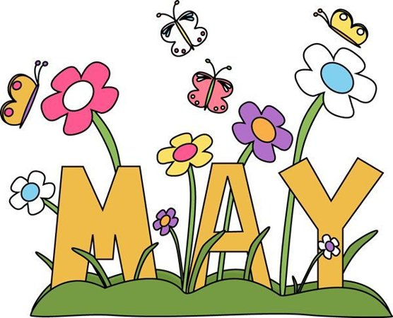 | Cambois Primary School  Newsletter  Early Years  In Early Years we have continued our topic 'Animal Safari. We have talked about what animals eat and if they are carnivores or herbivores. We have talked about the different habitats of animals and have begun to classify animals. The children have enjoyed searching for creatures in our outdoor environment, we found many animals including a newt!  Over the past few weeks we have read a selection of stories that were set in Africa including 'Little Red and the very Hungry Lion' and 'Handa's Hen'. We are currently reading 'Walking through the Jungle' and 'Super worm'. We have discussed the characters and events in the stories. The children made some marvellous lion masks.  In maths we have been developing our skills in shape and space completing puzzles and jigsaws. The tangram puzzles were tricky! The children displayed perseverance and high levels of engagement while trying to complete puzzles and build models. This week we have been developing our understanding of numbers to 10. We have been thinking about numbers that go together to make 10.  The children have been brilliant when sharing sets of objects into groups.  Outdoors the children have been enjoying water play and using the mud kitchen as well as the balance bikes. They have become more confident using the bikes and are showing more control.  Year 1 / 2  We had a fantastic day out at Warkworth Castle on Monday. The children were so engaged and inquisitive, asking lots of questions and doing lots of noticing and wondering about what the castle looked like in the past!  Beach School will continue and as the weather is getting warmer can we ensure children have sunscreen applied/spares brought in with them and appropriate clothing for the beach.  We have also enjoyed reading the poem 'The Spider and the Fly' this half term and have created some fantastic pieces of writing from it!  Year 3 / 4  Year 3 / 4 visited Clarty Commandos last Friday, they are also taking part in the cycling scheme which saw some of them take a trip to Gallagher park to the bike track. They also been making Islamic art sculptures.  Mrs. Darbyshire class also visited Clarty Commandoes and really enjoyed it  Year 5 / 6  Surfing - from next week (Wednesday 22nd May) and until the end of the summer term Year 6 along with some Year 5 students will be going surfing!  Dukes house Wood - Our residential trip is fast approaching. Please ensure you have updated your payments via School Ping. Children attending the residential will get a kit list and medical form this week to be filled out by Friday 24th May.  SATs - Huge congratulations to our Year 6s who have completed their SATs this week. They have shown great persistence and determination to complete some very tricky test papers.  Archaeological digs - Children in Years 3, 4, 5 and 6 will be participating in an archaeological dig outside the front of the school on Monday and Tuesday next week.  Ukulele - Children in Year 5 have been having ukulele lessons on a Monday morning and are looking to host a musical towards the end of term.
- Contact Us  Phone Number  01670 825218  Email  admin@cambois.northumberland.sch.uk  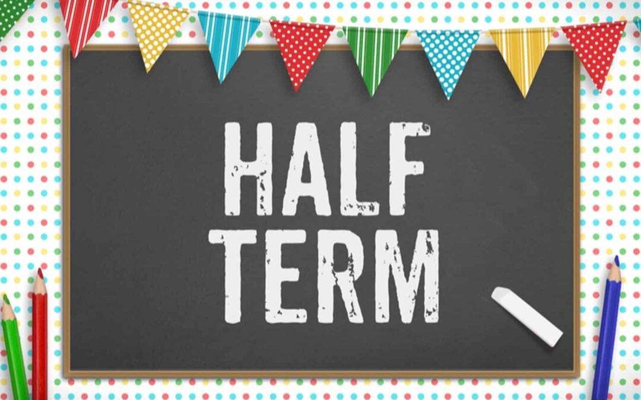  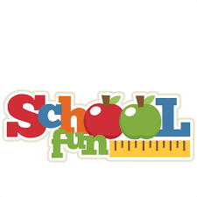 | Important Dates  22nd May- Year 5 Surfing  24th May- Break for Half Term  3rd June- Return to school  